1. KPI REQUIREMENT

* Total Revenue

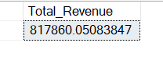select SUM(total_price) as Total_Revenue from pizza_sales

* Average Order Value

select SUM(total_price)/COUNT(order_id) as Average_Order_Value from pizza_sales



* Total Pizzas Sold

select SUM(quantity) as Total_Pizzas_sold from pizza_sales



* Total Orders

select COUNT(order_id) as Total_Orders from pizza_sales



* Average Pizzas Per orders

select CAST(CAST(SUM(quantity) as DECIMAL(10,2))/CAST(COUNT(DISTINCT order_id) as DECIMAL(10,2)) as DECIMAL(10,2)) as Average_pizzas_per_order from pizza_sales



1. CHART REQUIREMENT

* Daily Trend for Total Order

select DATENAME(DW,order_date) as ORDER_DAY ,COUNT(DISTINCT order_id) as Total_ORDERS from pizza_sales

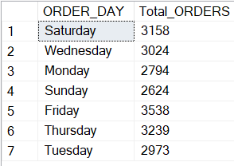group by DATENAME(DW,order_date)

* Monthly Trend for Total Order

select DATENAME(MONTH,order_date) as MONTH_NAME ,COUNT(DISTINCT order_id) as Total_ORDERS from pizza_sales

group by DATENAME(MONTH,order_date)

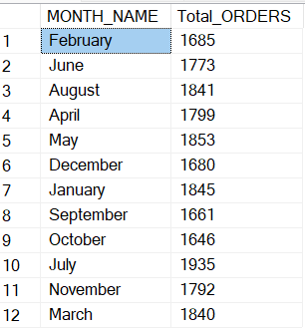

* Percentage of Sales by Pizza Category

select pizza_category,SUM(total_price)*100/(select SUM(total_price) from pizza_sales) as Percent_sale_by_category from pizza_sales

group by pizza_category

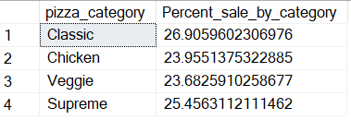

* Percentage of Sales by Pizza Size

select pizza_size,CAST(SUM(total_price) as DECIMAL(10,2))as Total_revenue,CAST(SUM(total_price)*100/(select SUM(total_price) from pizza_sales)as DECIMAL

(10,2)) as Percent_sale_by_size from pizza_sales

group by pizza_size

order by pizza_size

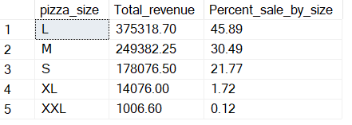

* Top 5 best sellers by Revenue, total quantity and total order

select top 5 pizza_name, SUM(total_price) as Total_revenue from pizza_sales

group by pizza_name

order by Total_revenue DESC

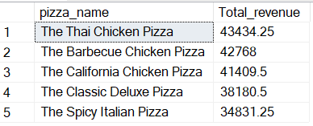

select top 5 pizza_name, SUM(quantity) as Total_quantity from pizza_sales

group by pizza_name

order by Total_quantity DESC

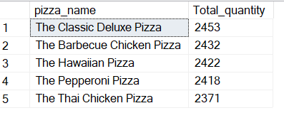

select top 5 pizza_name, COUNT(DISTINCT order_id) as Total_order from pizza_sales

group by pizza_name

order by Total_order DESC

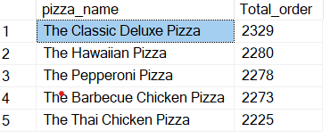

* Bottom 5 best sellers by Revenue, total quantity and total order

select top 5 pizza_name, SUM(total_price) as Total_revenue from pizza_sales

group by pizza_name

order by Total_revenue ASC

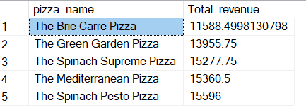

select top 5 pizza_name, SUM(quantity) as Total_quantity from pizza_sales

group by pizza_name

order by Total_quantity ASC

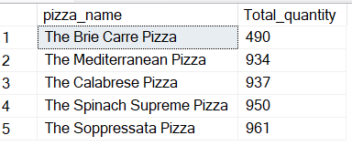

select top 5 pizza_name, COUNT(DISTINCT order_id) as Total_order from pizza_sales

group by pizza_name

order by Total_order ASC

